 COMSATS University Islamabad, Lahore

FALL 2020
□ Sessional-1 □ Sessional-II □ Terminal Examination
Course Title: | Semantic Web (Lab) |  |  |  | Course Code: |  | CSE344 | Credit Hours: | 3(2,1)
Course Instructor/s: | Sana Rizwan |  |  |  | Program Name: |  | BSSE
Semester: | 7th | Batch: | FA17 | Section: | B |  | Date:
Time Allowed: | 1 Hour 15 minutes |  |  |  | Maximum Marks: |  |  | 30
Student’s Name: |  |  |  |  | Reg. No.
Important Instructions / Guidelines:
- Rewriting and cuttings are not allowed. All questions are compulsory.

Question 1: (Marks = 6)

Write an RDF/XML code with proper RDF elements for the given statements.
1Anna isMotherOf John

2. hasAdmissionFee has domain BCSC and range University

3. Women is a subclass of Person using RDF/RDFS language syntax

Question 2: (Marks = 8)

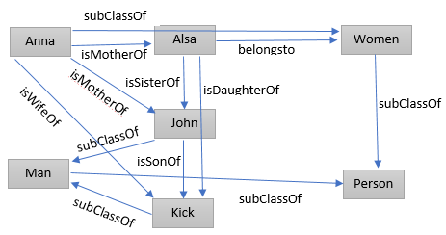

A. Fill the missing Triples with given RDF graph.

1. Anna ________ Alsa
2. Alsa belongsto __________
3. ______ subClassOf Person
4. Anna ________ Kick
5. Anna isMotherOf __________
6. ______ subClassOf Women
7. Alsa __________ John
8. John isSonOf __________
9. ______ isDaughterOf __________
10. Kick ___________ Man
11. Man subClassOf __________
12. _____ belongsto Man

 | 1. Anna ________ Alsa  2. Alsa belongsto __________  3. ______ subClassOf Person  4. Anna ________ Kick  5. Anna isMotherOf __________  6. ______ subClassOf Women  7. Alsa __________ John  8. John isSonOf __________  9. ______ isDaughterOf __________  10. Kick ___________ Man  11. Man subClassOf __________  12. _____ belongsto Man

B. Fill missing Relational Form from the given RDF graph:

1. isMotherOf (__________, Alsa)
2. belongsto (Alsa, _________ )
3. __________ (Women, Person)
4. isWifeOf (_______,_______)
5. isMotherOf (________, John)
6. __________ (Anna, Women)
7. __________ (Alsa, John)
8. isSonOf (_______, Kick)
9. isDaughterOf (______, _____)
10. subClassOf (_______, Man)
11. subClassOf (Man, ________)
12. belongsto (________, Man)

 | 1. isMotherOf (__________, Alsa)  2. belongsto (Alsa, _________ )  3. __________ (Women, Person)  4. isWifeOf (_______,_______)  5. isMotherOf (________, John)  6. __________ (Anna, Women)  7. __________ (Alsa, John)  8. isSonOf (_______, Kick)  9. isDaughterOf (______, _____)  10. subClassOf (_______, Man)  11. subClassOf (Man, ________)  12. belongsto (________, Man)

Question 3: (Marks = 6)

Define a vocabulary about Hotel using FOAF with RDF resources in given sequence.
- Declare information using particular resource = http://www.information.com/~hotel/contact.rdf#Avari
- Define email resource = mailto:avari.gm@information.com
- Homepage of resource = http://www.information.com/~hotel/avari/
- Declare first_name of hotel representative
- Declare last_name of hotel representative

Question 4: (Marks = 4)

Gadgets in Daraz.pk are Laptop, Air pod, Mobile, Play Station and Digital Watches
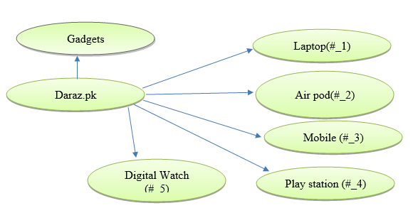
- Daraz.pk is a shopping gadgets resource from http://daraz.pk/gadgets
- Daraz.pk has list of items declared in RDF bag
- Title of #_2 should be in sequence as first_name and last_name
- Title of #_3 can have alternative name Tab

Question 5: (Marks = 4)

Write a code in XHTML+RDFa having identified features.
- XML declaration
- HTML declaration with concerned PREFIXES
- Head Tag declaration with Title
- Body Tag with DC information and external resource calling from http://cricketpk.org/resource/2020_FALL_IPL to get the data of 2020 FALL IPL

THE END

